**Media Query Breakpoints**

How to check web-page is mobile friendly or not?

<https://search.google.com/test/mobile-friendly>

copy the web-page URL and paste it in above site then test and view results.

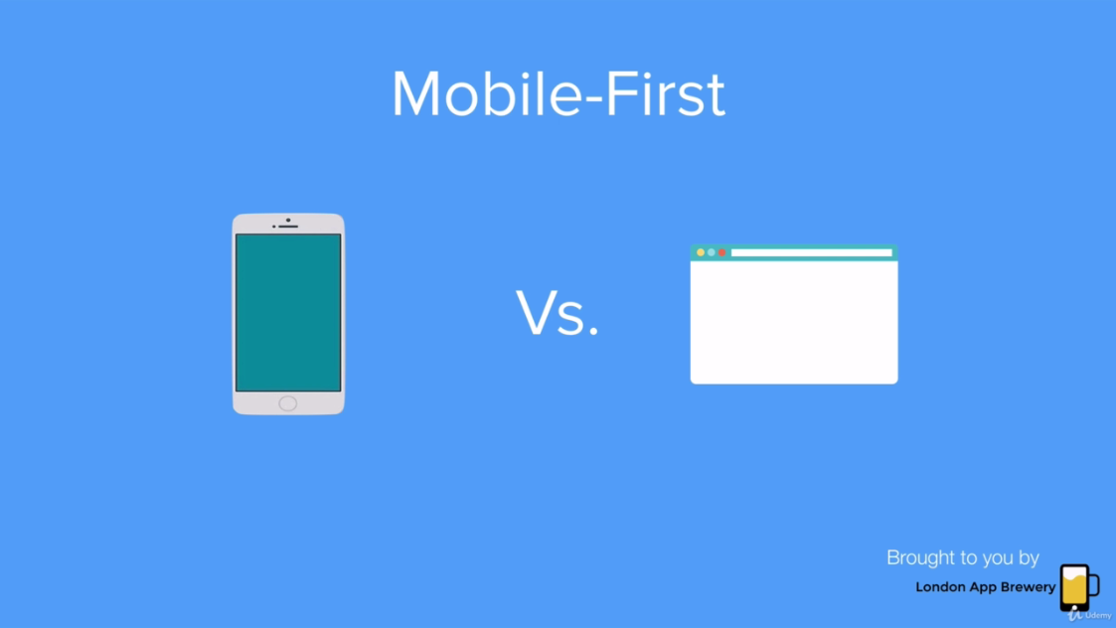

**Ways to Make your website perfect on mobile & pc**

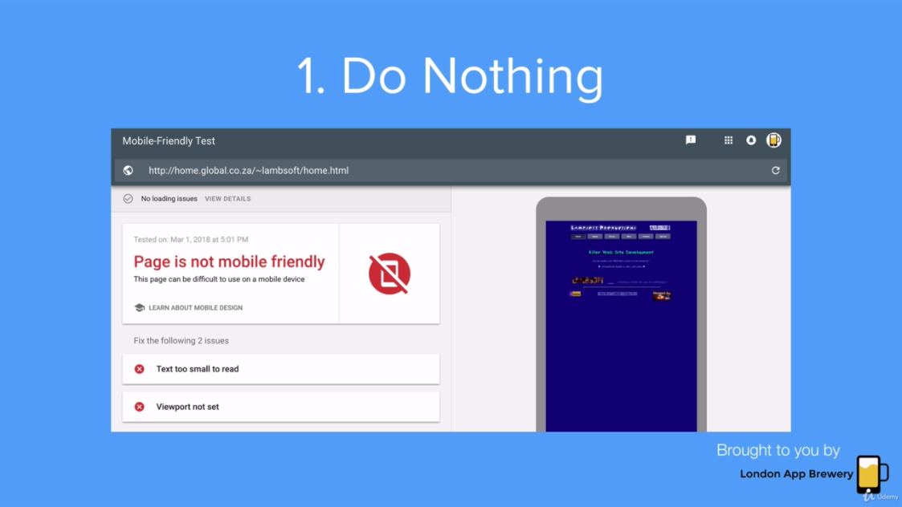

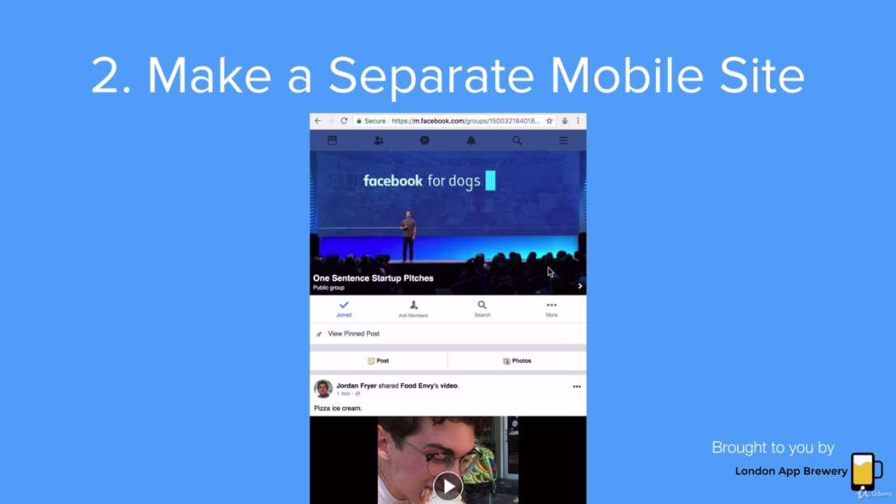

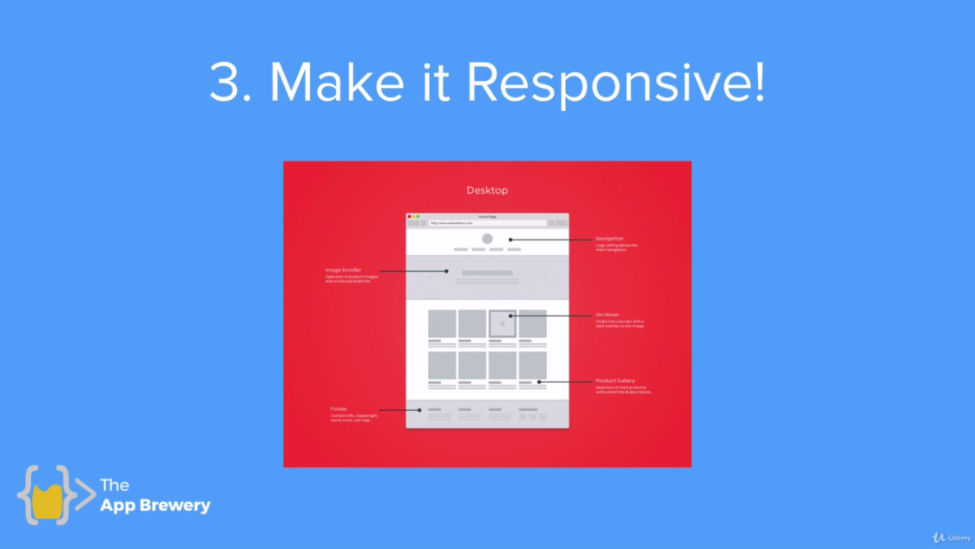

**HTML:**

<h1>Hello World!</h1>

**CSS:**

@media print{

h1{

color:red;

}

}

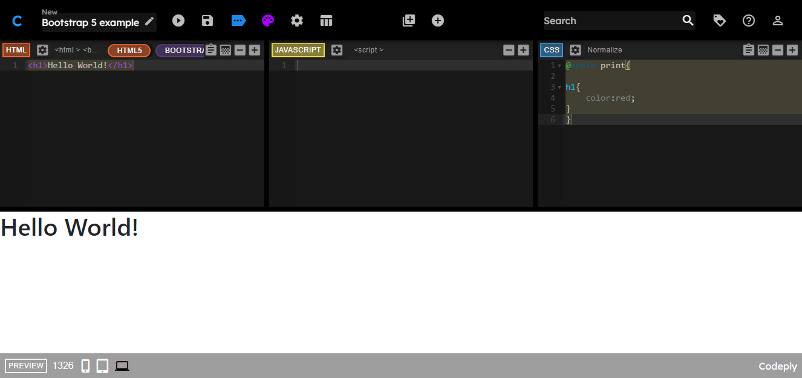

But when I print this it shows h1 color: red as shown below.

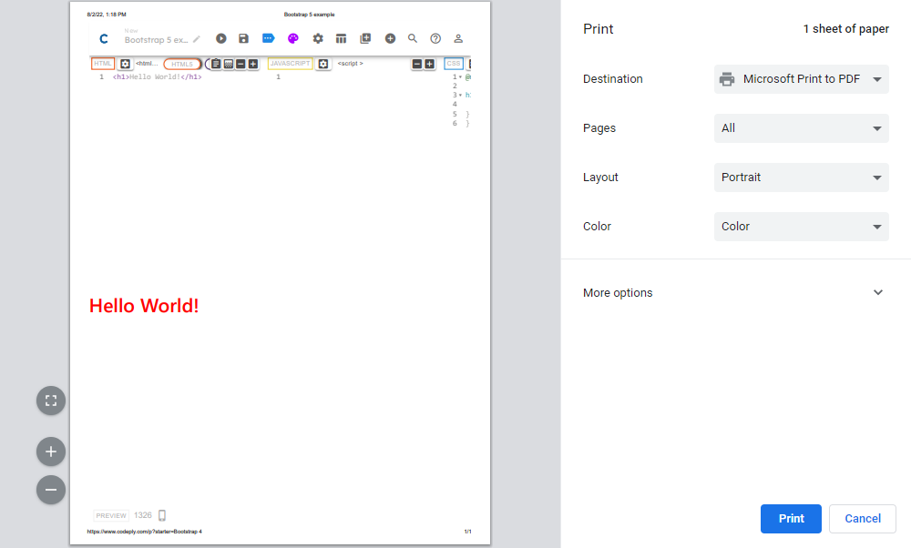

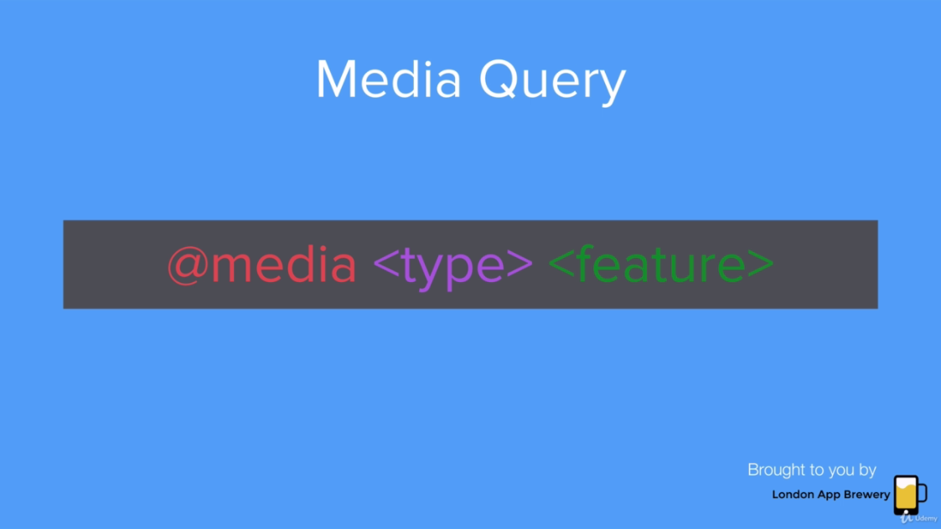

# @media

The **@media** [CSS](https://developer.mozilla.org/en-US/docs/Web/CSS) [at-rule](https://developer.mozilla.org/en-US/docs/Web/CSS/At-rule) can be used to apply part of a style sheet based on the result of one or more [media queries](https://developer.mozilla.org/en-US/docs/Web/CSS/Media_Queries/Using_media_queries). With it, you specify a media query and a block of CSS to apply to the document if and only if the media query matches the device on which the content is being used.

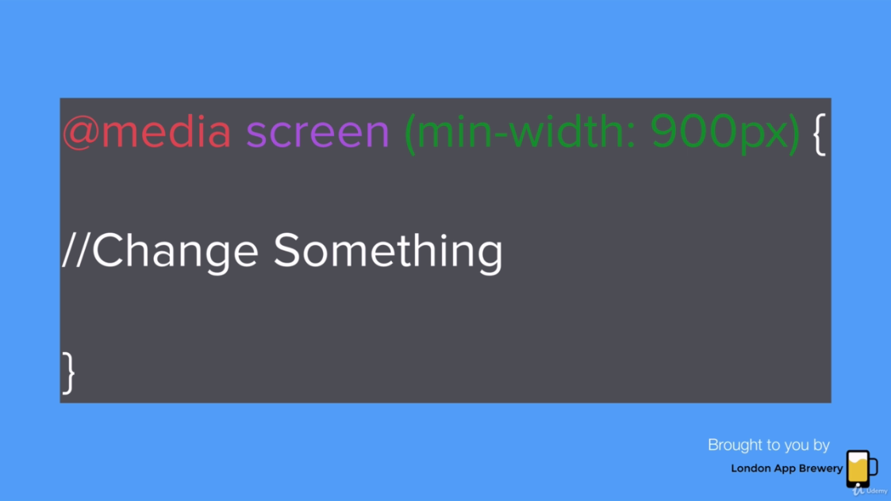

@media print{

h1{

color:red;

}

}

@media (max-width:900px){

/* If the width is 900px or less then change the h1 color */

h1{

color:red;

}

}

h1{

font-size:30px; //when width is greater than 900px

}

@media (max-width:900px){

h1{

font-size:60px; //when width is rqual to 900px

}

}

h1{

font-size:30px;

}

@media (min-width:900px) and (max-width:1000px){

/* 2 conditions (Nested Condition) when width range is 900px to 1000px */

h1{

font-size:60px;

}

}

**Code:**

**Index8.html:**

<!DOCTYPE html>

<html lang="en" dir="ltr">

<head>

<meta charset="utf-8">

<title>TinDog</title>

<!-- Google Fonts -->

<link rel="stylesheet" href="http://fonts.googleapis.com/css?family=Monserrat|Ubuntu">

<!-- Add Bootstrap Here-->

<!-- Stylesheet -->

<link rel="stylesheet" href="https://cdn.jsdelivr.net/npm/bootstrap@4.0.0/dist/css/bootstrap.min.css" integrity="sha384-Gn5384xqQ1aoWXA+058RXPxPg6fy4IWvTNh0E263XmFcJlSAwiGgFAW/dAiS6JXm" crossorigin="anonymous">

<link rel="stylesheet" href="css/styles7.css">

<!--Add style sheet-->

<!-- Font Awesome -->

<script defer src="http://use.fontawesome.com/releases/v5.0.7/js/all.js"></script>

<!--Add awsome fonts and icons like button icons-->

<!-- Link JavaScript of Bootstrap -->

<!-- Bootstrap Scripts -->

<script src="https://code.jquery.com/jquery-3.2.1.slim.min.js" integrity="sha384-KJ3o2DKtIkvYIK3UENzmM7KCkRr/rE9/Qpg6aAZGJwFDMVNA/GpGFF93hXpG5KkN" crossorigin="anonymous"></script>

<script src="https://cdn.jsdelivr.net/npm/popper.js@1.12.9/dist/umd/popper.min.js" integrity="sha384-ApNbgh9B+Y1QKtv3Rn7W3mgPxhU9K/ScQsAP7hUibX39j7fakFPskvXusvfa0b4Q" crossorigin="anonymous"></script>

<script src="https://cdn.jsdelivr.net/npm/bootstrap@4.0.0/dist/js/bootstrap.min.js" integrity="sha384-JZR6Spejh4U02d8jOt6vLEHfe/JQGiRRSQQxSfFWpi1MquVdAyjUar5+76PVCmYl" crossorigin="anonymous"></script>

</head>

<body>

<!-- section 1 -->

<section id="title">

<div class="container-fluid">

<!-- Nav Bar -->

<nav class="navbar navbar-expand-lg navbar-dark ">

<!-- Make transparent Header so remove bg-dark -->

<a class="navbar-brand" href="">tindog</a>

<button class="navbar-toggler" type="button" data-bs-toggle="collapse" data-bs-target="#navbarTogglerDemo02" aria-controls="navbarTogglerDemo02" aria-expanded="false" aria-label="Toggle navigation">

<span class="navbar-toggler-icon"></span>

</button>

<div class="collapse navbar-collapse" id="navbarTogglerDemo02">

<ul class="navbar-nav ml-auto">

<li class="nav-item">

<a class="nav-link" href="">Contact</a>

</li>

<li class="nav-item">

<a class="nav-link" href="">Pricing</a>

</li>

<li class="nav-item">

<a class="nav-link" href="">Download</a>

</li>

</ul>

</div>

</nav>

<!-- title -->

<div class="row">

<!--Now take a row and divide it into 2 columns of large 6 units -->

<div class="col-lg-6">

<!-- First column contains heading and buttons -->

<h1>Meet new and interesting dogs nearby.</h1>

<button type="button" class="btn btn-dark btn-lg download-button"><i class="fab fa-apple"></i> Download</button>

<button type="button" class="btn btn-outline-light btn-lg download-button"><i class="fab fa-google-play"></i> Download</button>

</div>

<div class="col-lg-6">

<!-- @nd column contains image -->

<img class="title-image" src="D:\University\Web Notes\Web Development Codes\CSS\TinDog Start Here\images\iphone6.png" alt="iphone-mockup"> <!-- Or simply link is images\iphone6.png -->

</div>

</div>

</div>

</section>

<!-- Next Sectioon starts here section 2 -->

<!-- Features -->

<section id="features">

<div class="row">

<div class="feature-box col-lg-4">

<i class="icon fas fa-check-circle fa-4x"></i> <!-- check circle icon 4x is size -->

<h3>Easy to use.</h3>

<p>So easy to use, even your dog could do it.</p>

</div>

<div class="feature-box col-lg-4">

<i class="icon fas fa-bullseye fa-4x"></i> <!-- bullseye icon -->

<h3>Elite Clientele</h3>

<p>We have all the dogs, the greatest dogs.</p>

</div>

<div class="feature-box col-lg-4">

<i class="icon fas fa-heart fa-4x"></i> <!-- heart icon -->

<h3>Guranteed to work.</h3>

<p>Find the love of your dog's life or your money back</p>

</div>

</div>

</section>

<!-- Next Sectioon starts here section 3 -->

<!-- Testimonials -->

<section id="testimonials">

<div id="testimonial-carousel" class="carousel slide" data-ride="false">

<div class="carousel-inner">

<div class="carousel-item active">

<h2>I no longer have to sniff other dogs for love. I've found the hottest Corgi on TinDog. Woof.</h2>

<img class="testimonial-image" src="images\dog-img.jpg" alt="dog profile">

<em>Pebbles, New York</em>

</div>

<div class="carousel-item">

<h2 class="testimonial-text">My dog used to be so lonely, but with TinDog's help, they've found the love of their life.

I think.</h2>

<img class="testimonial-image" src="images/lady-img.jpg" alt="lady-profile">

<em>Beverly, Illinois</em>

</div>

</div>

<a class="carousel-control-prev" href="#testimonial-carousel" role="button" data-slide="prev">

<span class="carousel-control-prev-icon"></span>

</a>

<a class="carousel-control-next" href="#testimonial-carousel" role="button" data-slide="next">

<span class="carousel-control-next-icon"></span>

</a>

</div>

</section>

<!-- Next Sectioon starts here section 4 -->

<!-- Press -->

<section id="press">

<img class="press-logo" src="images\TechCrunch.png" alt="tc-logo">

<img class="press-logo" src="images\tnw.png" alt="tnw-logo">

<img class="press-logo" src="images\bizinsider.png" alt="biz inseider-logo">

<img class="press-logo" src="images\mashable.png" alt="mashable-logo">

</section>

<!-- Next Sectioon starts here section 5 -->

<!-- Pricing -->

<section id="pricing">

<h2>A Plan for Every Dog's Needs</h2>

<p>Simple and affordable plan for you and your dog.</p>

<!--<div class="card-deck"> This class is used to place cards horizontally -->

<div class="row">

<div class="pricing-column col-lg-4 ">

<div class="card "> <!-- col-md-6 when this site is opened in mobile or tab it will change site cards layout -->

<div class="card-header">

<h3>Chihuahua</h3>

</div>

<div class="card-body">

<h2>Free</h2>

<p>5 Matches Per Day</p>

<p>10 Messages Per DAy</p>

<p>Unlimited App Usage</p>

<button class=" btn-lg btn-block btn-outline-dark" type="button">Sign Up</button>

</div>

</div>

</div>

<div class="pricing-column col-lg-4 ">

<div class="card">

<div class="card-header">

<h3>Labrador</h3>

</div>

<div class="card-body">

<h2>$49 / mo</h2>

<p>Unlimited Matches</p>

<p>Unlimited Messages</p>

<p>Unlimited App Usage</p>

<button class=" btn-lg btn-block btn-dark" type="button">Sign Up</button>

</div>

</div>

</div>

<div class="pricing-column col-lg-4 ">

<div class="card">

<div class="card-header">

<h3>Mastiff</h3>

</div>

<div class="card-body">

<h2>$99 / mo</h2>

<p>Pirority Listing</p>

<p>Unlimited Matches</p>

<p>Unlimited Messages</p>

<p>Unlimited App Usage</p>

<button class=" btn-lg btn-block btn-dark" type="button">Sign Up</button>

</div>

</div>

</div>

<!--</div> -->

</div>

</section>

<!-- Next Sectioon starts here section 6 -->

<!-- Call To Action -->

<section id="cta">

<h3>Find the True Love of Your Dog's Life Today.</h3>

<button type="button">Download</button>

<button type="button">Download</button>

</section>

<!-- Next Sectioon starts here section 7 -->

<!-- Footer -->

<section id="footer">

<p>© Copyright TinDog</p>

</section>

</body>

</html>

**Styles7.css:**

/************************ TAG SSELECTORS **********************/

/* These are global tags because they change the whole body */

h1{

font-family: "Montserrat-Black";

font-size: 3.5rem;

line-height: 1.5;

font-weight: bold;

}

h2{

font-family: "Montserrat-Bold";

font-size: 3rem;

line-height: 1.5;

font-weight: bold;

}

h3{

font-family: "Montserrat-Bold";

}

p{

color: #8f8f8f;

}

body{

font-family: "Monserrat";

}

/************************ CLASS SSELECTORS **********************/

.container-fluid{

padding: 3% 15% 7%;

}

/* Navigatioon Bar */

.navbar{

padding: 0 0 4.5rem; /* 0 on top 0 on left and right and 4.5rem on bottom */

}

.navbar-brand{

font-family: "Ubuntu"; /* tindog t style changes */

font-size: 2.5rem;

font-weight: bold;

}

.nav-item{

padding: 0 18px;

}

.nav-link{

font-size: 1.2rem;

font-family: "Montserrat-Light";

}

/* Download Buttons */

.download-button{

margin: 5% 3% 5% 0; /* top=5%, right=3%, bottom=5%, left=0 */

}

/* Title Image */

.title-image{

width: 60%;

transform: rotate(25deg); /* Rotate image to style */

right: 30%; /* or margin-right: 30%; */

position: absolute;

/* z-index: -1; */

}

.feature-box{

text-align: center;

padding: 4.5%;

}

.icon{

color: #ef8172;

margin-bottom: 1rem;

}

.icon:hover{

color: #ff4c68;

}

/* Testimonial Section */

.testimonial-image{

width: 10%;

border-radius: 100%;

margin: 20px;

}

/* Press Section */

.press-logo{

width: 15%;

margin: 20px 20px 50px;

}

/* Carousel Section */

.carousel-item{

padding: 7% 50px;

height: 500px;

}

/* Pricing Section */

.pricing-column{

padding: 3% 2%;

}

/************************ ID SSELECTORS ************************/

#title{

background-color: #ff4c68;

color:#fff; /* white = #fff */

}

/* Features Section */

#features{

padding: 7% 15%;

background-color: #fff; /*white*/

position: relative; /* This position is to move image z index */

/* z-index: 1; // This part hides some part of image behind features section */ /* Postion is moved as required. See flow chart to learn this. */

}

/* Testimonial Section */

#testimonials{

padding: 7% 15%;

text-align: center;

background-color: #ef8172;

color: #fff;

}

/* Press Section */

#press{

background-color: #ef8172;

text-align: center;

padding-bottom: 3%;

}

/* Pricing Section */

#pricing{

padding: 100px;

text-align: center;

}

/* Media Query Breakpoints */

@media (max-width:1028px) { /* If width is less or equal to 1028px then this property holds */

#title{

text-align: center;

}

.title-image{

position: static;

transform: rotate(0);

}

}